Elmwood Cemetery
Perth, Ontario

The Gates of Elmwood

The gates of Elmwood Cemetery are left open, to give an inviting and welcoming feeling to all who wish to use the cemetery’s park-like setting. The cemetery has regular visitors, walkers and joggers passing through the gates most days of the week.

Welcome to Elmwood Cemetery
Elmwood Cemetery is owned and operated by The Perth Cemetery Company, a not-for-profit organization and a registered Canadian charity. The company, which was founded in 1872, is governed by an active volunteer Board of Directors. We are located in the Town of Perth, Lanark County, Ontario and we are the only operating cemetery within the Town of Perth.

Our property encompasses fifty-one acres of which about fifteen acres are presently used for interments. While Elmwood was originally founded as the Anglo-Protestant cemetery for the general Perth area, it expanded many decades ago to serve all area residents without concern for their cultural or religious backgrounds.

Elmwood serves the citizens of Perth and surrounding communities by providing a secure and affordable final resting place in a park like setting. The monuments, structures and trees represent the historical link to the past and the area’s inhabitants that have gone before us.
-----------------------------------
Board of Trustees

Diana Cross, Chairperson
Ed Sherwin, Vice Chairperson
David Batchelor, Treasurer/Admin
Jeannie Seguin, Secretary
Doug Cox, Assistant Secretary
Laura Murray, Heritage Records
Rebecca Cox
Tom Ennis
Brent McLaren

Memorial Service

Sunday, July 14, 2024
2:00 pm

Thank you for joining us today.

The service will be preceded by the brief Annual General Meeting

www.elmwoodcemeteryperth.ca

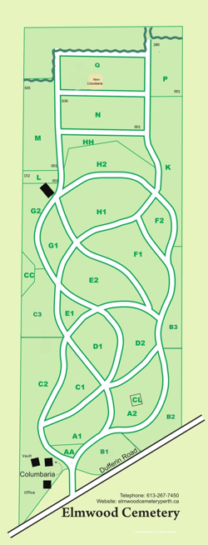

Elmwood Cemetery Map
Donations
Donations are used to augment the perpetual funds that are used to maintain the cemetery and are welcome at any time. The donations are used for specific maintenance projects such as marker maintenance, tree trimming and roads.

The cemetery is a registered charity and tax receipts are available for donations of $25 and over.

If you would like to make a donation, cheques should be made payable to:

Perth Cemetery Company

Please ensure that your full name and address are on your cheque, etransfer or envelope so that we can issue a tax receipt.

The donations can be either placed in the basket as you are leaving or mailed to the Office:

Perth Cemetery Company
165 Dufferin Road
Perth, Ontario K7H 3B4

Donations can also be made by e-transfer to accounts@elmwoodcemeteryperth.ca (the account has auto-deposit so no password is required).

Registered Charity No: 127301901


Fresh floral pieces left from today’s Memorial Service are to be removed by July 31st.

In Memoriam
June 1, 2023– May 31, 2024
Hess, David
  McFarlane, Margaret
  Noiles, Blennis
  Bennett, Gerry
  Frizell, Beatrice
  Johnson, Dorothy
  Lowry, Barbara
  Beswick, John
  Barr, Ken
  Couch, Barbara
  Schiel, Martha
  Spence, David
  Brown, Dorothy
  Demiannay, Pascal
  Holowaczuk, Elizabeth
  McAusland, Joyce
  Christopher, John
  Mara, Carolynne
  Poynton, Rosemary
  Laporte, Henriette
  Burke, Jean
  Smith, Paul
  Horne, Carol Anne
  Griffin, Philip
  Webster, Gary
  Dalgleish, Annita
  Livingston, Jean
  Livingston, Keith
  McCallum, Gordon
  Villeneuve, Grace
  Scarrow, Edna
  Hayward, Alan
  Allan, Marie
  Middleton, Linda
  Thomas, Milton
  Thomas, Norma
  Neate, Caroline
  McCabe, John
  McLeod, Eunice
  McConnell, Shirley
  Myers, Shirley
  Ackerman, John
  Moore, Oliver
  Rogers, Grace
  Holl, Gisela
  Hogan, Norma
  Price, Lorraine
  Buchanan, Norman
  Blais, Johanna
  Richardson, Eunice
  Sherwin, Donald
  Warrington, Daphne
  Hale, Pauline
  Dulmage, Debbie
  Duby, Charles
  Barr, Jean
  Moyle, Ronald
  Nazar, Loretta Ann
  Valiquette, Leo
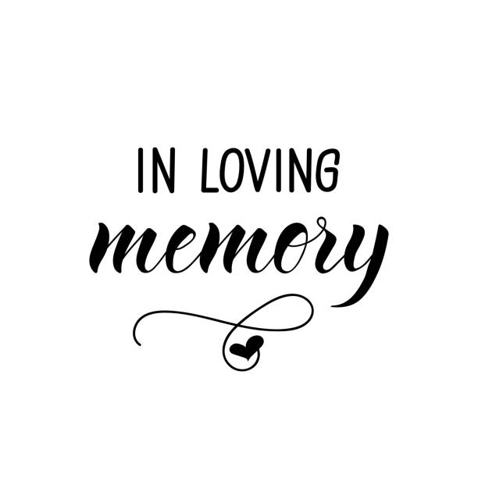
 | Singer, Eileen
 | Currie, Georgina Marlene
 | Fournier, Frances Lynne
 | Purdon, William
 | Mather, Gladys
 | Hacker, Roger
 | Watson, William
 | Chaplin, Doris Mae
 | Farrell, Iona
 | Price, Gary
 | Harper, Delwyn
 | Pettigrew, Robert
 | Young, Ruth
 | Moore, Norma
 | Collison, Evangiline
 | Bothwell, Evelyn
 | Batoff, Andrew
 | Ward, Michael
 | Killingbeck, Darcy
 | Doucet, Dorothy

Cooe Delete Box

Programme
Welcome: Diana Cross

Musical Interlude: Tom Valliquette

Prayer: Rev. Arlyce Schiebout

In Memoriam: Trustees

Musical Interlude: Tom Valliquette

Scripture
& Meditation: Rev. Arlyce Schiebout

Musical Interlude: Tom Valliquette

Closing Prayer
& Blessing: Rev. Arlyce Schiebout
--------------------------------------------
Elmwood Cemetery Memorial Service for 2025

Sunday, July 13, 2025 at 2pm.

We hope that you will join us again next year.
--------------------------------------------
Services offered
At Elmwood we offer numerous options for the deceased such as traditional full interment (casket or vault), cremation interment (urn in ground), or inurnment (urn in a columbarium).
--------------------------------------------
What is New?
All floral arrangements must be removed by Oct 20th each year as we prepare for Fall cleanup.
Note: Arrangements placed after the Oct 20th Fall cleanup must be removed within 3 weeks.

Volunteers are welcome to assist and are always needed for the Fall cleanup.

